**OPERATING SYSTEMS**

**Laboratory 5**

Name:Ujash

Surname:Patel

Index number:36283

**Introduction**

* 10 points maximum.
* All commands must be executed in the Linux terminal. Don't use Linux GUI to solve the exercises.

**Exercise 1. (10 points – 2 points per command)**

Explain the meaning and show an example of how the following commands work in a Linux terminal:

**1. echo**

*What this instruction does?*

*Eco command is a build in Linux feature that prints out arguments as the stander output. Echo is commonly used to display text string or command result as messages.*

*Screenshot showing the operation of the command:*

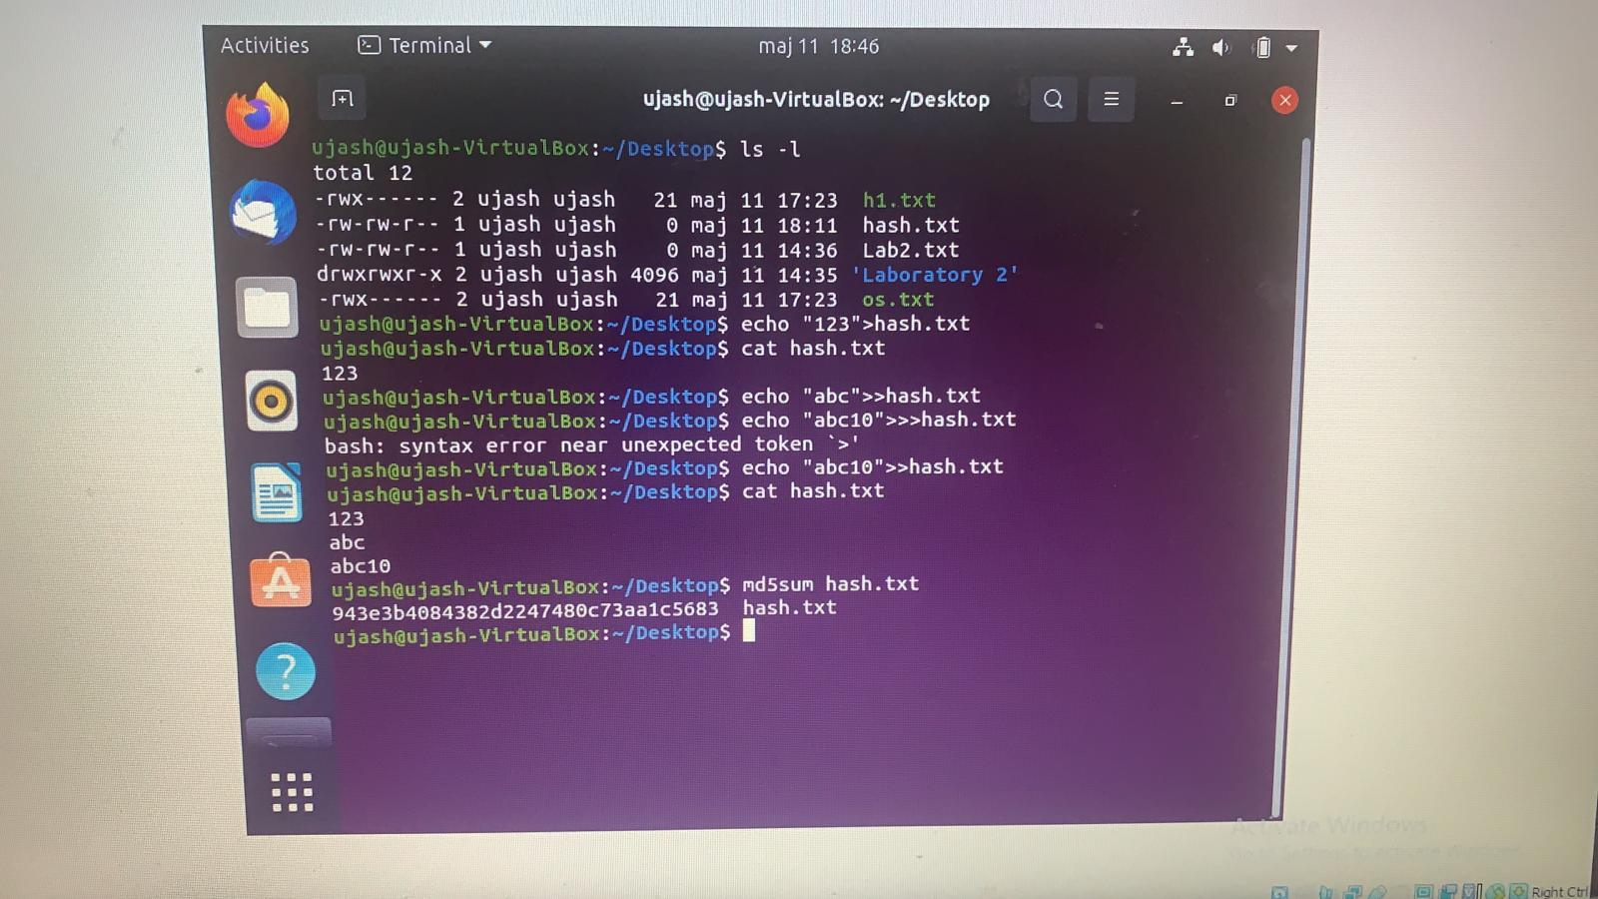

**2. top**

*What this instruction does?*

*Top command is used to show the Linux processes. It provides a dynamic real-time view of the running system. This command shows the summary information of the system and the list of processes or threads which are currently managed by linux kernel.*

*Screenshot showing the operation of the command:*

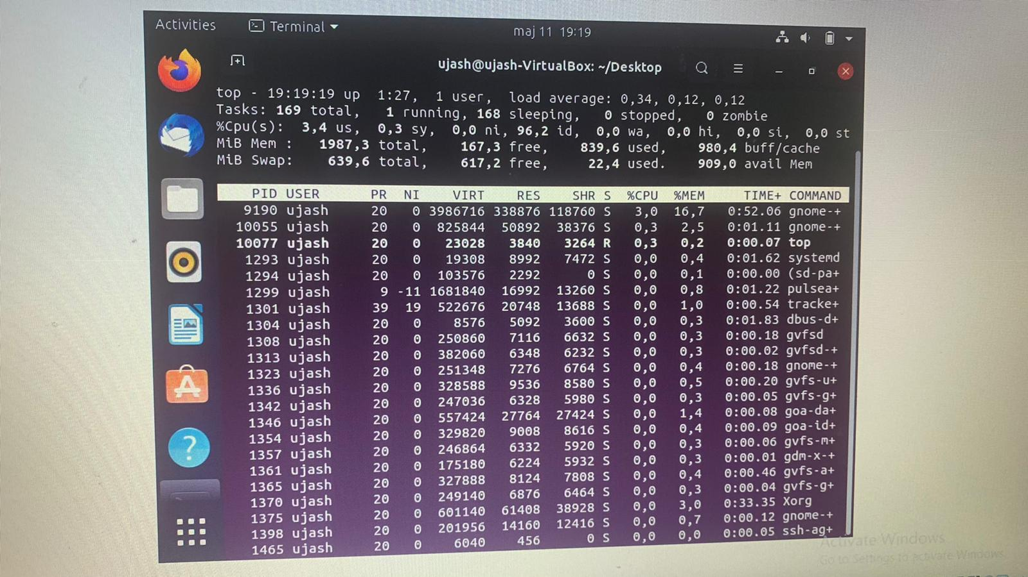

**3. ps**

*What this instruction does?*

*The ps command in linux is used to display about running processes on the system.*

*You can get information like process ID for the processes you or any other user is running on the same Linux system*

*Screenshot showing the operation of the command:*

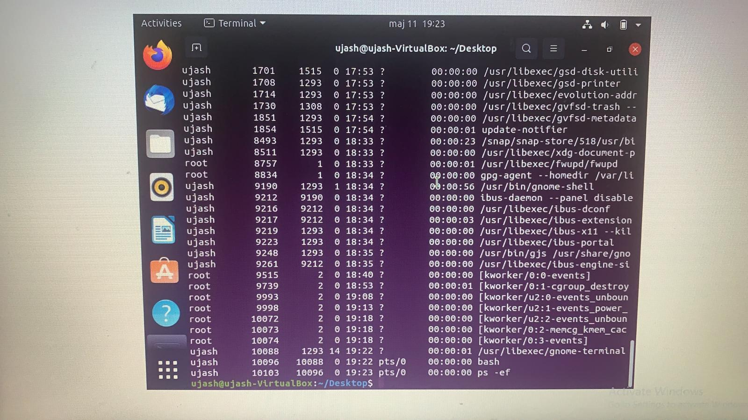

**4. chown**

*What this instruction does?’*

*The chown command in Linux allows you to change the ownership of files and directories.you can rightly guess that chown is short for change owner.*

*Screenshot showing the operation of the command:*

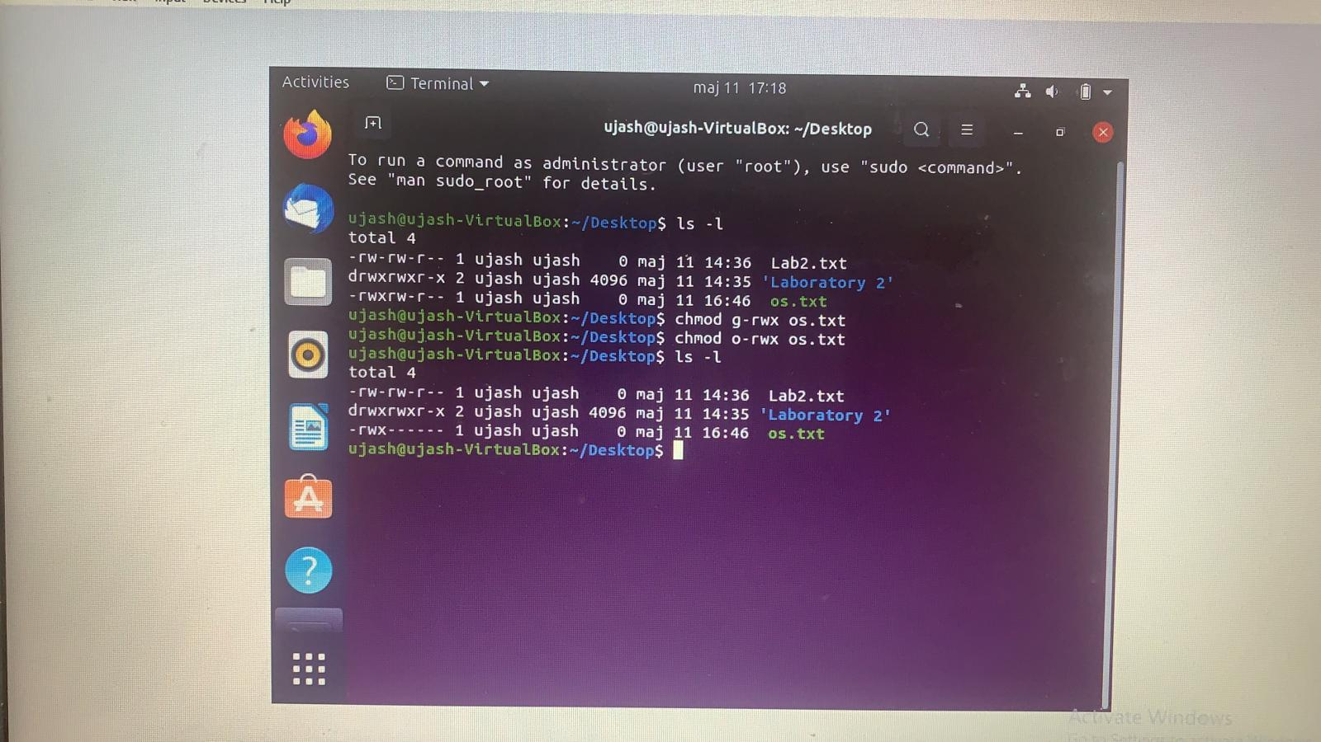

**5. grep**

*What this instruction does?*

*Greap is an essential Linux and Unix command. It is used to search text and strings in a given file. In other words , Grep command searches the given file for lines containing a match to the givine strings or words.*

*Screenshot showing the operation of the command:*

